MEMORANDUM

DEPARTMENT OF TRANSPORTATION
Project Development Branch

4201 East Arkansas Avenue
Denver, Colorado 80222
(303)757-9040
FAX (303)757-9868
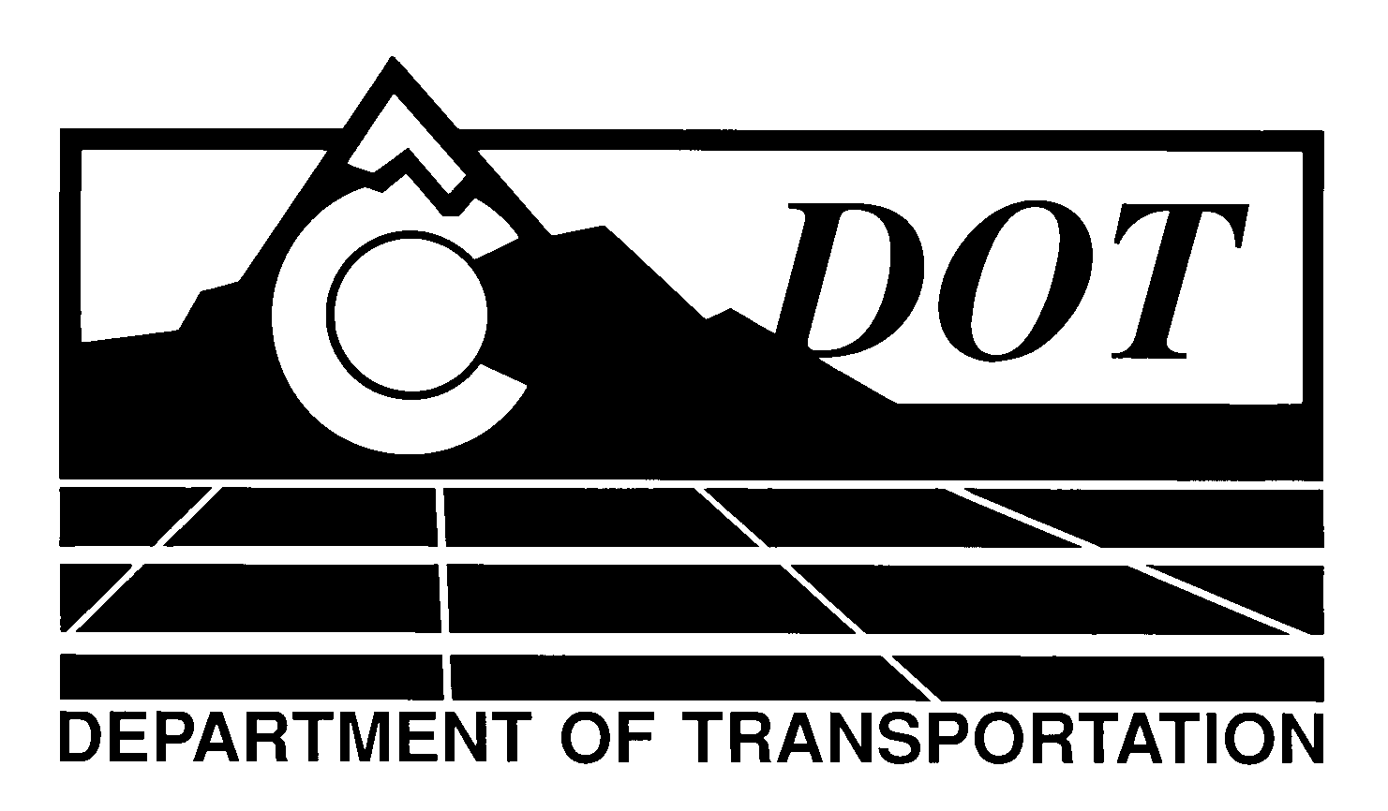

DATE: December 29, 2011

TO: All Holders of Standard Special Provisions

FROM: Larry Brinck, Standards and Specifications Engineer

SUBJECT: Revision of Section 108, Liquidated Damages

Effective this date, our unit is issuing a new standard special provision, Revision of Section 108, Liquidated Damages. This new standard special is 1 page long. It should be used in all projects, beginning with projects advertised on or after January 26, 2011. Please feel free, however, to include it in projects advertised before this date.

The modifications contained in this revision reflect recent calculations and adjustments to the liquidated damages, which are conducted every two years in accordance with 23 CFR 635.127 (a) and (b).

Those of you who keep books of Standard Special Provisions should add this one to your file. For your convenience, we are attaching a new Index of Standard Special Provisions, dated December 29, 2011. In addition, you will find this and other special provisions that are being issued this date in one place in the CDOT Construction Specifications web site:

http://www.coloradodot.info/business/designsupport/construction-specifications/2011-Specs

Please scroll to the hyperlink titled “Recently Issued Special Provisions” to access this and other special provisions that have been issued as of this date.

LB/mrs

Attachments

Distribution: Per distribution list

